Lab 07 – JavaScript Functions, Events, and DOM Manipulation
Lab Outcomes:
- Understand and apply JavaScript functions, events and DOM.
- Use various operators, functions in JavaScript, including arrow functions and DOM manipulation.
- Write basic JavaScript functions and event handling with conditional statements and expressions.

Introduction:
In this lab, we will explore the fundamental concepts of JavaScript, including its syntax and functions. JavaScript is essential for adding interactivity to web pages and is widely used in modern web development. By learning its basic functions and events, students will gain foundational knowledge that will help them write functional and efficient JavaScript code for web applications.

1. JavaScript Functions
JavaScript functions are reusable blocks of code designed to perform specific tasks. Functions make the code modular and easier to debug, reuse, and maintain. They can be categorized into several types based on their declaration style, behavior, and usage.

Types of Functions:
- Named Functions: Declared using the function keyword and invoked by their name.
function greet(name) {
return `Hello, ${name}!`;
}
console.log(greet("Alice"));
- Anonymous Functions: Functions without a name, often used as callbacks and used as arguments to other functions or assigned to variables.
const greet = function(name) {
return `Hello, ${name}!`;
};
console.log(greet("Bob")); // Output: Hello, Bob!
- Arrow Functions: Introduced in ES6, they provide a concise syntax for writing functions. They don’t have their own this and are often used for callbacks.
const add = (a, b) => a + b;
console.log(add(5, 3)); // Output: 8
- IIFE (Immediately Invoked Function Expression): Executed immediately after their definition. They are often used for creating a local scope or initialization.
(function() {
console.log("This is an IIFE");
})();

Constructor Functions : Functions used to create objects. They are invoked with the new keyword.
function Person(name, age) {
this.name = name;
this.age = age;
}
const person1 = new Person("Dave", 25);
console.log(person1.name); // Output: Dave

Generator Functions : Functions that can pause and resume their execution using the yield keyword.
function* generateNumbers() {
yield 1;
yield 2;
yield 3;
}
const gen = generateNumbers();
console.log(gen.next().value); // Output: 1
console.log(gen.next().value); // Output: 2
console.log(gen.next().value); // Output: 3

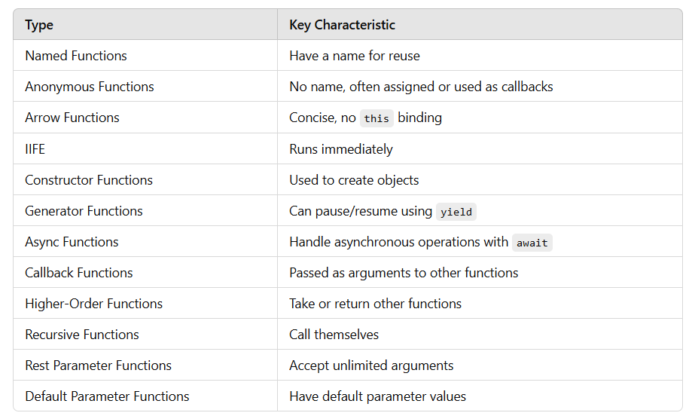
Functions can accept parameters to make them dynamic. Default values can be assigned to parameters.
function greet(name = "User") {
return `Welcome, ${name}`;
}
console.log(greet()); // Output: Welcome, User
console.log(greet("Charlie")); // Output: Welcome, Charlie

2. JavaScript Events
Events in JavaScript are actions or occurrences, such as a mouse click, a keypress, or page loading, that the browser recognizes and responds to. In Javascript it is the process of capturing and responding to events triggered by user interactions or browser actions. Events include user actions like clicking, hovering, or typing, and system actions like loading a page or resizing the browser window.

Common Events:
- Mouse Events: click, dblclick, mouseover, mouseout, mousedown, mouseup
- Keyboard Events: keydown, keypress, keyup
- Form Events: submit, change, focus, blur
- Window Events: load, resize, scroll, unload

Event Handling Methods

Inline Event Handlers
Usage: Specify the event handler directly in the HTML element.
<button onclick="alert('Button clicked!')">Click Me</button>

DOM Element Property
Usage: Assign a function to the event property of an element.
const button = document.getElementById('myButton');
button.onclick = function() {
alert('Button clicked!');
};

addEventListener
Usage: Attach multiple event listeners to the same element, or handle different events separately.
const button = document.getElementById('myButton');
button.addEventListener('click', function() {
alert('Button clicked using addEventListener!');
});

Event Object
When an event occurs, an event object is passed to the event handler, containing information about the event.
document.addEventListener('click', function(event) {
console.log(`Clicked at coordinates (${event.clientX}, ${event.clientY})`);
});

Common Use Cases
Prevent Default Behavior
Some elements have default behaviors, like links navigating to another page. Use event.preventDefault() to prevent this.
document.querySelector('a').addEventListener('click', function(event) {
event.preventDefault();
alert('Default action prevented!');
});

Delegation
Handle events for multiple elements efficiently by attaching a single listener to a common ancestor.
document.getElementById('list').addEventListener('click', function(event) {
if (event.target.tagName === 'LI') {
alert(`You clicked on ${event.target.textContent}`);
}
});
<ul id="list">
<li>Item 1</li>
<li>Item 2</li>
<li>Item 3</li>
</ul>

Removing Event Listeners
To remove an event listener, use removeEventListener. The function reference must match the one used in addEventListener.
function handleClick() {
alert('Button clicked!');
}
button.addEventListener('click', handleClick);
button.removeEventListener('click', handleClick);
Example
<!DOCTYPE html>
<html>
<head>
<title>Real-Time Text Update</title>
<script>
function updateText() {
const input = document.getElementById("userInput").value;
document.getElementById("display").innerText = input;
}
</script>
</head>
<body>
<h1>Type Something</h1>
<input type="text" id="userInput" onkeyup="updateText()">
<p id="display">Your text will appear here.</p>
</body>
</html>

3. DOM Manipulation
The DOM (Document Object Model) is a programming interface provided by browsers that represents an HTML or XML document as a tree structure. It allows developers to access, modify, or manipulate the content, structure, and styling of a webpage dynamically using JavaScript.

Common DOM Methods:
- getElementById(id): Select an element by ID.
- querySelector(selector): Select the first element matching a CSS selector.
- createElement(tagName): Create a new HTML element.
- appendChild(node): Add a new child node to an element.
- removeChild(node): Remove an existing child node.

Key Concepts of the DOM
- Tree Structure:
  - Each HTML element is a node in the tree.
  - Nodes have relationships like parent, child, and sibling.
- Root Node:
  - The root node of the DOM is the document.
- Node Types:
  - Element Nodes: Represent HTML elements (e.g., <div>, <p>)
  - Text Nodes: Represent text content inside elements.
  - Attribute Nodes: Represent attributes of elements (e.g., class="example").

DOM Manipulation
DOM manipulation refers to modifying the structure, content, and style of the DOM using JavaScript. It is essential for creating dynamic, interactive web pages.

Accessing the DOM
JavaScript provides multiple methods to access elements in the DOM:
- getElementById: Access an element by its ID.
const element = document.getElementById("myElement");
- getElementsByClassName: Access elements by their class name (returns a collection).
const elements = document.getElementsByClassName("myClass");
- getElementsByTagName: Access elements by their tag name (returns a collection).
const elements = document.getElementsByTagName("p");
- querySelector: Access the first element matching a CSS selector.
const element = document.querySelector(".myClass");
- querySelectorAll: Access all elements matching a CSS selector (returns a NodeList).
const elements = document.querySelectorAll(".myClass");

Manipulating the DOM
- Change Content
  - innerHTML: Modifies the inner HTML of an element.
const element = document.getElementById("content");
element.innerHTML = "<strong>Updated Content</strong>";
  - textContent: Modifies only the text of an element (ignores HTML tags).
const element = document.getElementById("content");
element.textContent = "Updated Text";
- Change Attributes
  - setAttribute: Add or modify an attribute.
const link = document.querySelector("a");
link.setAttribute("href", "https://example.com");
  - getAttribute: Retrieve an attribute's value.
const link = document.querySelector("a");
console.log(link.getAttribute("href"));
  - removeAttribute: Remove an attribute.
const link = document.querySelector("a");
link.removeAttribute("href");
- Change Style
  - Modify styles directly via the style property.
const box = document.querySelector(".box");
box.style.backgroundColor = "blue";
box.style.color = "white";
- Add / Remove Class
element.classList.add("newClass");

element.classList.remove("oldClass");

element.classList.toggle("active");

element.classList.contains("active");

Creating and Removing Elements
- Create Elements
- createElement: Create a new HTML element.
const newElement = document.createElement("div");
newElement.textContent = "Hello, World!";
document.body.appendChild(newElement);
- Remove Elements
- remove: Remove an element.
const element = document.getElementById("myElement");
element.remove();
- removeChild: Remove a child element.
const parent = document.getElementById("parent");
const child = document.getElementById("child");
parent.removeChild(child);

Traversing the DOM
JavaScript allows navigation between nodes in the DOM tree:
Parent Node:
const child = document.getElementById("child");
const parent = child.parentNode;
Child Node:
const parent = document.getElementById("parent");
const children = parent.childNodes; // Includes text nodes
const childElements = parent.children; // Only element nodes
Siblings:
const element = document.getElementById("sibling");
const next = element.nextElementSibling;
const previous = element.previousElementSibling;

Example:
<!DOCTYPE html>
<html>
<head>
<title>DOM Manipulation Example</title>
</head>
<body>
<div id="container">
<p id="text">Original Text</p>
<button id="changeText">Change Text</button>
<button id="addElement">Add Element</button>
</div>

<script>
// Change text content
document.getElementById("changeText").addEventListener("click", () => {
const text = document.getElementById("text");
text.textContent = "Text Changed!";
});

// Add a new element
document.getElementById("addElement").addEventListener("click", () => {
const newElement = document.createElement("p");
newElement.textContent = "New Paragraph Added!";
document.getElementById("container").appendChild(newElement);
});
</script>
</body>
</html>

Lab Task
- Write a JavaScript function that generates a multiplication table for a user-defined number and displays it dynamically on the webpage.
- Create a simple interactive to-do list where users can add tasks, mark them as completed, and remove tasks dynamically.
- Create an input field and a button to add tasks.
- Each task should have a "Mark as Completed" button to toggle its status.
- Add a delete button to remove tasks.

Lab Assessment Criteria
Lab # 09 Marks Distribution

 | ER1 | ER6 | ER8 | RR1
Task | 3 Points | 2 Points | 3 Points | 2 Points
Lab # 09 Rubrics Evaluation Guidelines

# | Qualities & Criteria | 0 < Poor <=4 | 4.1 < Satisfactory <= 7 | 7.1 < Excellent <=10
ER1 | Task Completion | Minimal or no program functionality was achieved. | Some tasks were completed, but the program had errors or was incomplete. | All tasks were completed, and the program runs without errors.
# | Qualities & Criteria | 0 < Poor <=4 | 4.1 < Satisfactory <= 7 | 7.1 < Excellent <=10
ER6 | Program Output | Output is inaccurate or poorly presented. | Output is mostly accurate but may lack labels, captions, or formatting. | Output is clear, accurate, and well presented with labels, captions, and proper formatting.
# | Qualities & Criteria | 0 < Poor <=4 | 4.1 < Satisfactory <= 7 | 7.1 < Excellent <=10
ER8 | Question & Answer | Answers some questions but not confidently or based on lab task knowledge. | Answers most questions confidently and based on lab task knowledge | Answers all questions confidently and demonstrates a deep understanding of the given lab task.
# | Qualities & Criteria | 0 < Poor <=4 | 4.1 < Satisfactory <= 7 | 7.1 < Excellent <=10
RR1 | Report Structure and Clarity | Report is poorly organized, difficult to navigate, and lacks professional formatting. | Report is mostly organized but may have some minor structural issues or formatting inconsistencies. | Report is well-organized with a clear logical flow, easy navigation, and professional formatting.

